**Experiment No**: 02

**Title**: Configuration & Implementation of Ring Topology

**Problem Statement:**

To learns how to configure multiple pc to connect to switch for packet transmission in Cisco packet tracer simulation software.

**Objective:**

Multiple devices are connected with switches. We will build a network between the devices via switches and devices so that we can send massages or data using that network.

**Hypothesis:**

At first we made a proper connection by setting up IP address of each PC and provide a Next hope IP address for packet transmission.

**Materials:**

Cisco Packet Tracer Software

**Devices:**

1. 4 Switches
2. 4 PC
3. Copper straight cable
4. Serial DCE

**Procedure:**

* Design the connection using Cisco Packet Tracer Software like figure 1

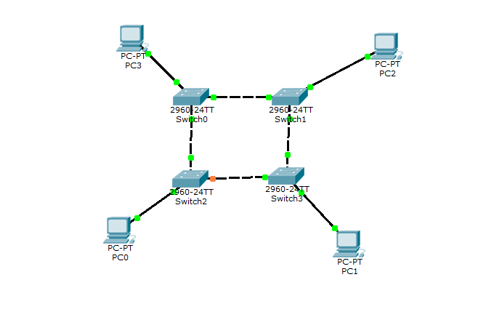

Figure: 01

* Connect 4 pc with switch0, switch1, switch2, switch3 (2960)
* And then each switch connect with 1 pc(2960)
* **IP Configuration:**

**PC0: PC1:**

IP: 10.0.0.1 IP: 10.0.0.2

Subnet mask: 255.0.0.0 Subnet mask: 255.0.0.0

Gateway: 10.0.0.1 Gateway: 10.0.0.1

**PC2: PC3:**

IP: 10.0.0.3 IP: 10.0.0.4

Subnet mask: 255.0.0.0 Subnet mask: 255.0.0.0

Gateway: 10.0.0.1 Gateway: 10.0.0.1

* Here all the PCs are connected to the different networks and routers connect them. All the configurations are properly done that’s why the connections are green.
* Select message option and select the sender and receiver
* If the connections are properly made and networks are properly set then we can send packet from one network to another.

**Discussions:**

* We must check all the connections and IP addresses to ensure successful data transfer.
* If the number of computer increases then the communication will become more complex.
* Switching speed is an important factor here.